**MME P2 Final Report**

Dr. Heidi Ploeg, Dr. Roshni Rainbow

APSC 200/293

Mechanical Engineering

Faculty of Engineering and Applied Science

Queen’s University

**Prepared by Team 16, Section 204**

Elly Jones, 20226916

Stacey Goldberg, 20268542

Park Lan-Liu, 2029986

Max McCutcheon, 20228127

Conrad Bierman, 20294181

***April 10, 2023***

# Statement of Originality

Our signatures below attest that this submission is our original work.

Following professional engineering practice, we bear the burden of proof for original work. We have read the Policy on Academic Integrity posted on the Faculty of Engineering and Applied Science website (<http://engineering.queensu.ca/policy/Honesty.html>) and confirm that this work is in accordance with the Policy.

**Individual 1:**

|  |  |  |  |  |
| --- | --- | --- | --- | --- |
| Signature: |  | Date: | | 2023-02-13 |
| Name: | Stacey Goldberg | ID #: | 20268542 | |

**Individual 2:**

|  |  |  |  |
| --- | --- | --- | --- |
| Signature: |  | Date: | 2023-02-13 |
| Name: | Max McCutcheon | ID #: | 20228127 |

**Individual 3:**

|  |  |  |  |
| --- | --- | --- | --- |
| Signature: |  | Date: | 2023-02-13 |
| Name: | Conrad Bierman | ID #: | 20294181 |

**Individual 4:**

|  |  |  |  |
| --- | --- | --- | --- |
| Signature: |  | Date: | 2023-02-13 |
| Name: | Elly Jones | ID #: | 20226916 |

**Individual 5:**

|  |  |  |  |
| --- | --- | --- | --- |
| Signature: |  | Date: | 2023-02-13 |
| Name: | Park Lan-Liu | ID #: | 20299860 |

Table of Contents

Statement of Originality i

Table of Tables iii

List of Figures iii

1.0 Introduction 1

1.1 Problem Statement 1

2.0 Background 1

2.1 Comparable Systems 1

2.1.1 Model Rocket Parachute Systems 1

2.1.2 Manned Parachutes 2

2.1.3 Drogue Chutes 3

2.2 Principles of Parachute Design 4

2.3 Design Process 7

2.3.1 Test Launch #1 7

2.3.2 Test Launch #2 7

2.3.3 Launch #3 8

2.3.4 Final Design Changes Post Launch 8

3.0 Design, Testing and Analysis 8

3.1 Description of Final Design 8

Endcap Holes 8

Capsule Flaps 9

The Parachute Folding 10

3.2 Testing and Analysis 11

4.0 Conclusion 15

References 16

Appendix A: Individual Contributions 17

Appendix B: Cost Break-down 18

Appendix C: Design Constrains 19

# 

# Table of Tables

Table 1: Provided table of Mitchel Hall measurements. 14

Table 2: Table of contributions of each team member 17

# List of Figures

Figure 1: Example of a model rocket assembly and its components. 2

Figure 2: Manned parachute example. 3

Figure 3: Drogue chute deployment 3

Figure 4: Diagram of deployed parachute system and payload 4

Figure 5: Diagram of forces applied to edge of parachute canopy 5

Figure 6: Diagram of the pressurized air pushing outwards once the parachute is deployed. 5

Figure 7: A free body diagram of deployed parachute 6

Figure 8: Endcap with three holes drilled into it. 9

Figure 9: Visual of components and demonstration of capsule flaps. 10

Figure 10: Assembly of parachute and payload in capsule. 11

Figure 11 : Visual of initial design before testing 12

Figure 12 : Still image of panels doing the opening function as intended 13

Figure 13: Parachute deployment system at max apogee 14

Figure 14:Visualization of the materials previously listed. 18

# Introduction

This report will discuss the design process and background theory for the chosen parachute deployment system. The objectives and system restrictions will be discussed in Section 1.1 below. Section 2.0 will review comparable systems for recovery of similar objects such as drones and discuss the principles of parachute design. This section will also go over the team’s design process for determining an optimal parachute deployment system for the project. Section 3.0 will both review the final chosen design in detail and review the testing process done to get to this final design.

## 1.1 Problem Statement

Parachute deployment is a desirable option for medical supply delivery as it is a rapid form of transport, low impact, and poses low risks to public safety [1]​. Integrating parachutes into drones and other Unmanned Aerial Vehicles (UAVs) has become increasingly popular for pilots [2]​. They can also be useful for drone recovery in case of a system failure, ensuring that any goods being transported by the drone will land safely onto the ground [2]​. A model rocket and parachute deployment system will be designed and manufactured to simulate this medical supply delivery. The design must deploy a parachute within an altitude of 12 m, hold a high payload, have a passive deployment system, while preventing breakage of material. Materials have been provided by the client including a rocket capsule, parachute, carabiner, and nose cap.

# 2.0 Background

## 2.1 Comparable Systems

This section will discuss comparable rocket and parachute systems such as the model rocket system, manned parachute system, and drogue chutes, as well as their similarities and applications to the project.

### 2.1.1 Model Rocket Parachute Systems

Model rockets are small, powered crafts built from predominantly cardboard materials designed to emulate full size rockets [3]. They are typically launched at low altitudes and incorporate a recovery system that uses a parachute. The components of a typical model rocket system can be seen in Figure 1below.

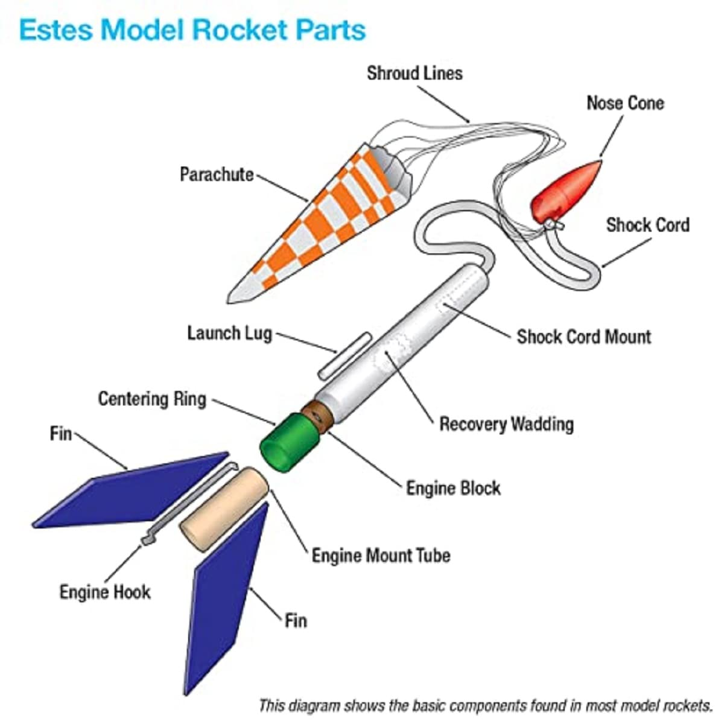

Figure : Example of a model rocket assembly and its components.

Unlike the parachute used during the P2 project which must have a passive method of deployment, a model rocket's parachute is deployed with a timed charge. This charge is designed to ignite when the fuel of the main rocket thrusters has completely been consumed. It blows off the nose cone of the rocket forcing out the parachute, which will catch air and slow the descent of the model rocket [4]. Out of all analogous systems discussed, the parachutes utilized by model rockets are the most similar in size, design, and materials to those found in the P2 capsule.

### 2.1.2 Manned Parachutes

There are numerous styles and designs of parachutes used for human descent. The most common type of parachute design is a ram air parachute, in which a rectangular canopy with an upper and lower surface is inflated by air entering an opening at the front of the canopy and forming an airfoil [5]. A diagram of a manned parachute can be seen in Figure 2below. This provides the distinct advantage of added structural stability, allowing for speed control and steerability. A ram air parachute design would not be optimal for the project recovery system. While a modern ram air parachute is an excellent design, its complexity and costly production would ultimately be wasted in controllability, a feature that would be of no use for capsule recovery or real world unmanned medical deliveries.

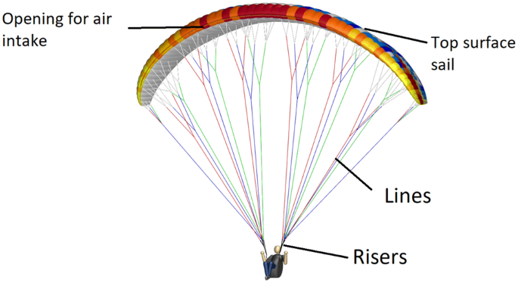

Figure : Manned parachute example.

A much more similar, albeit outdated design of manned parachute is the round parachute. They resemble the simple, round cut of fabric inside the project's capsule. They were phased out of use because of their lack of control [6].

### 2.1.3 Drogue Chutes

Drogue chutes are parachutes designed for deployment under high velocity. They are designed to decrease speed and provide stability. Drogue chutes have a multitude of uses, like slowing aircraft upon landing in spacecraft recovery systems, and as a pilot chute to deploy larger parachutes [7]. They differ from parachutes in that they are longer with a smaller surface area and provide less drag. A diagram displaying how a drogue chute deploys can be seen in Figure 3below.

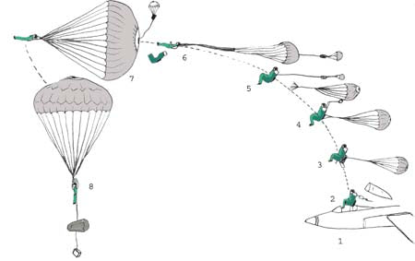

Figure : Drogue chute deployment

As opposed to slowing an object to a safe speed, they are designed for high-velocity scenarios where a regular parachute may explode upon deployment or cause a high impulse. Drogue parachutes are already widely used for payload delivery from cargo airplanes like the Lockheed C-130 Hercules to decelerate the aircraft, and by extension its cargo, during airdrop operations [8]. A drogue chute was conceptualized in the early stages of the design process in the form of a smaller external 9-inch parachute. Its purpose was to provide enough drag force to separate the system from the capsule, but it was ultimately scrapped in favour of the folding doors design.

## 2.2 Principles of Parachute Design

A parachute is a device used to slow the motion of a payload using the drag force as it descends through the atmosphere. The drag area of a payload prior to parachute deployment is relatively small compared to the area of the parachute. The parachute canopy is attached to the suspension lines, which is in turn attached to the suspended body. A basic diagram of the system is show in Figure 4.

Figure 4: Diagram of deployed parachute system and payload

The force resulting from the mass of the suspended body is transferred to the suspension lines and canopy. A vertical and horizontal force component is applied at the base of the canopy, shown in Figure 5. The inwards direction of the horizontal components tends to pull the canopy closed, but as the canopy moves down through the air, a large bubble of pressurized air is captured as shown in Figure 6. The resultant forces from the internal pressure of the air bubble push outwards, and counteract the forces applied by the suspension lines [9].

Figure 5: Diagram of forces applied to edge of parachute canopy

Figure 6: Diagram of the pressurized air pushing outwards once the parachute is deployed.

Looking at the parachute mass system in Figure 7, there are two external forces acting on it. These are gravity and drag.

Figure 7: A free body diagram of deployed parachute

According to Newtons Second Law of Motion which is the sum of forces equals the mass multiplied acceleration, the acceleration of the system is equal to the net force divided by the mass of the system. When the force of gravity is higher than the drag force, the net force will be in the downward direction, and the system will accelerate down. When the drag force is greater than the force of gravity, the system will decelerate down. The force of gravity on the system stays constant, but the drag force is relative to v2.  As the system accelerates downward from an unbalanced net force, the force of drag increases as the velocity increases. When the forces become equal, the net force and in turn the acceleration becomes 0, the velocity reaches a constant and the system reaches an equilibrium point. The velocity of the system at the equilibrium point is known as terminal velocity [10].

|  |  |
| --- | --- |
| . | (1) |
|  | (2) | |
|  |  |

The force of drag is calculated with the equation 1 above. Where is the density of fluid, is the desired terminal velocity, is the drag coefficient which is fixed once a chute type is selected, and being the cross-sectional area. As previously stated, at terminal velocity, the drag force and weight are equal and can be substituted. Rearranging for area, equation 2 is determined, in which the required cross-sectional area can be calculated with these fixed values and plugging in the desired terminal velocity [11].

## 2.3 Design Process

Throughout the design process, the capsule system underwent some initial smaller design changes, and then a large evolution in design after the second test launch. The hinged door system was the final design chosen for the project.

### 2.3.1 Test Launch #1

The first test launch resulted in a successful deployment, and a second launch was not attempted. No irreversible changes were made to the given components before the first launch. The first design exclusively concerned the parachute folding and packing technique, relying on the centripetal force of the capsule to deploy the parachute once launched. One side of the carabiner was hooked into the three loops of the parachute, and the other was linked with the cap eyelet and the canister. The parachute folding technique was taken from the website Apogee Components, a seller and resource guide for all forms of model rocketry [12]. This process involved folding the parachute in half across a set of two corners and in half again perpendicular to the first fold. One quarter was folded in to bring all 6 strings together, and another in half along the middle. The strings, now collected into one bundle, were folded in half, and placed along the parachute and the system was carefully loaded to prevent unraveling. This folding method was decided upon to reach a comfortable middle ground between being tight enough so that there is minimal friction from the parachute leaving the tube, and not so tight that the parachute is still able to unravel and catch air before it reaches the ground.

### 2.3.2 Test Launch #2

Before the second launch day, the design was kept functionally the same, excepting three small holes that were drilled into the secure end cap attached to the capsule. These were intended to allow some of the launch air to push into the tube against the parachute, and to eliminate the vacuum that pulls the parachute back into the capsule. This launch day was less successful, with one out of two attempts deploying successfully. The team felt that the deployment of the parachute was largely based on luck and decided to change the design for the third launch day to produce a more reliable model.

### 2.3.3 Launch #3

The updated model consists of a completely new capsule design. Three equally spaced parallel cuts were made along half the length of the tube and were cut off to create three flaps of 12.6 centimeters long. Electrical tape was placed along the inside and outside of the flaps parallel to the tube to reattach the cut material to the remaining launch tube, acting as a hinge. A strip of tape was wound around the outside of the tube to further secure the hinge tape. This design served two distinct purposes. The first was to eliminate the problem of the friction force holding the tube and chute system together and instead allowing the flaps to open around the parachute in mid air. The second purpose was to create a drag force on the capsule upon launch and opening, pushing the capsule and system apart. The team was able to successfully launch the capsule, and the parachute deployed as desired all three times this day.

### 2.3.4 Final Design Changes Post Launch

The third and last round of design modifications was relatively minimal compared to the last overhaul, in lieu of the team's success during the second launch day. The parachute was wrapped in a different manner because it was noted that because of the effectiveness of the design, the parachute was opening and deploying in the upwards motion too quickly, not reaching the full desired apogee. The parachute was wrapped tightly with the intention of catching air and deploying later. It was noted that since the capsule did not have its own parachute to minimize costs, it would often impact the ground with a high velocity. Extra tape was added along exposed edges to reinforce the structural integrity of the tube.

# 3.0 Design, Testing and Analysis

## 3.1 Description of Final Design

All of the changes made to the capsule from its base design can be summarized in three parts: the holes in the end cap, the opening flaps on the capsule and the parachute folding method. As mentioned in the previous sections, all of these design changes were acquired through testing. This description here is of the final design components and why it is believed they aided in the final success.

### Endcap Holes

As the launcher functions by using compressed air when being launched, the capsule experiences a large force from the high-pressure air on the bottom endcap. By drilling the 3 small holes in the bottom endcap (Figure 8)it allows some of the high-pressure air into the capsule, this does two things, first removes any potential for a vacuum holding the endcap onto the capsule, and second will allow some of the air to press against the top endcap and push it away from the capsule early on.

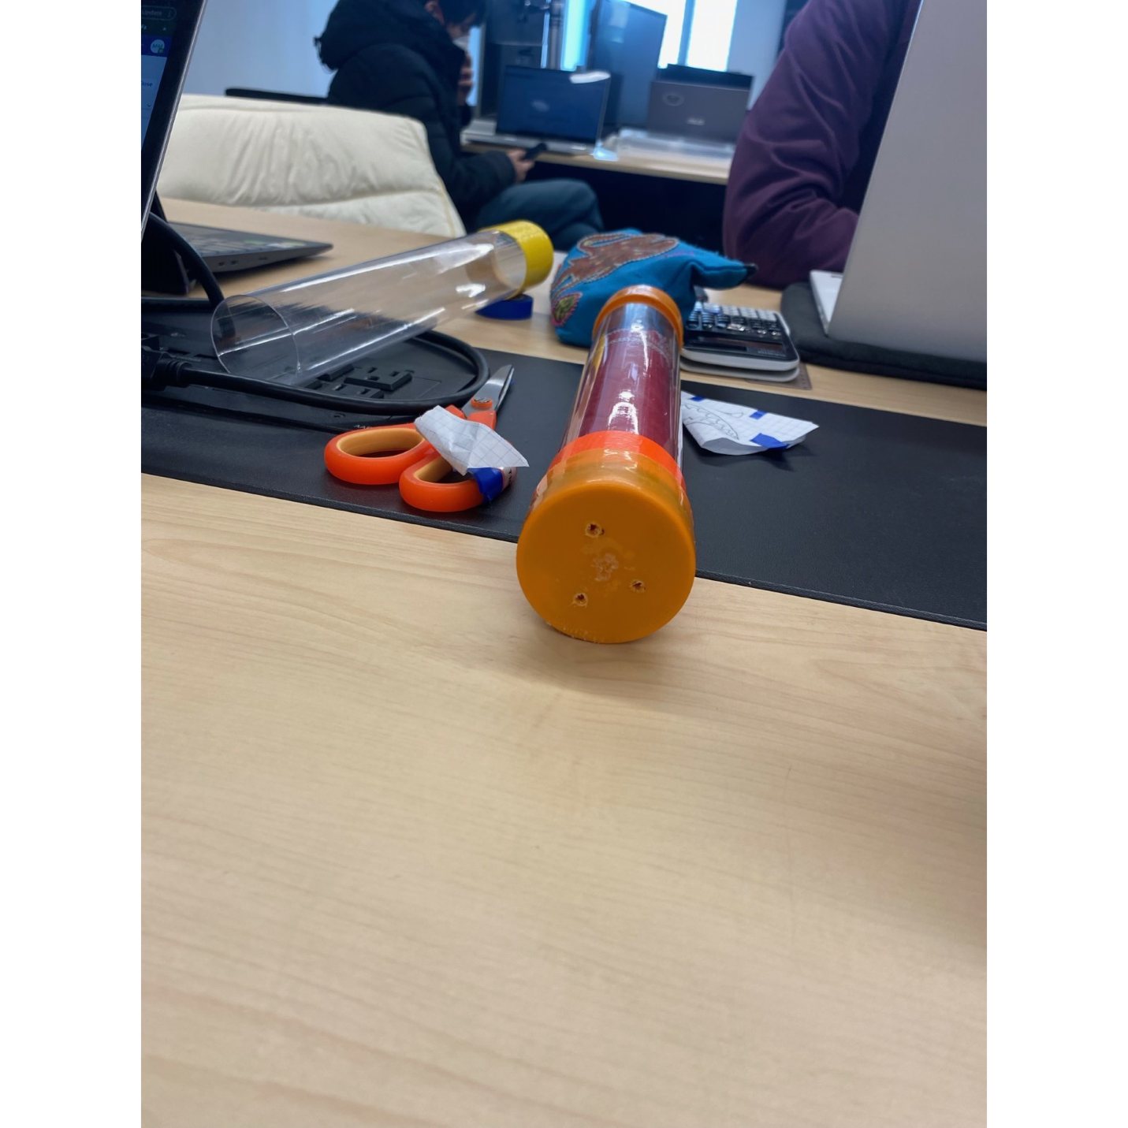

Figure 8: Endcap with three holes drilled into it.

### Capsule Flaps

The capsule flaps, consisting of three equally sized pieces (Figure 9)serves two purposes. First to open and reduce the amount of plastic actually touching the parachute and thereby reducing friction so that the parachute can leave the capsule as easily as possible. And secondly, to produce as much drag as possible when opening, this immense amount of drag slows the capsule massively and forces it away from the parachute and payload very quickly. This modification leads to consistent launches where the capsule opens immediately after leaving the tube, and then is completely removed from the parachute and payload within 2-3 meters of the launcher.

Figure 9: Visual of components and demonstration of capsule flaps.

### The Parachute Folding

The last design change was with the parachute folding method. This also comprised of two parts, the initial goal here was to fold the parachute itself with the most efficient and compact method to ensure it won’t get stuck in the tube, and but when needed will open quickly. However, the remaining string was then used to wrap up the parachute, Figure 10, this would stop it opening once in the open air and delay its deployment, but in a controlled fashion. In the launches with this method, each wind of string could be seen coming off, delaying the parachute deployment till close to the apex, when the string would finally unravel and then the parachute would deploy unhindered.

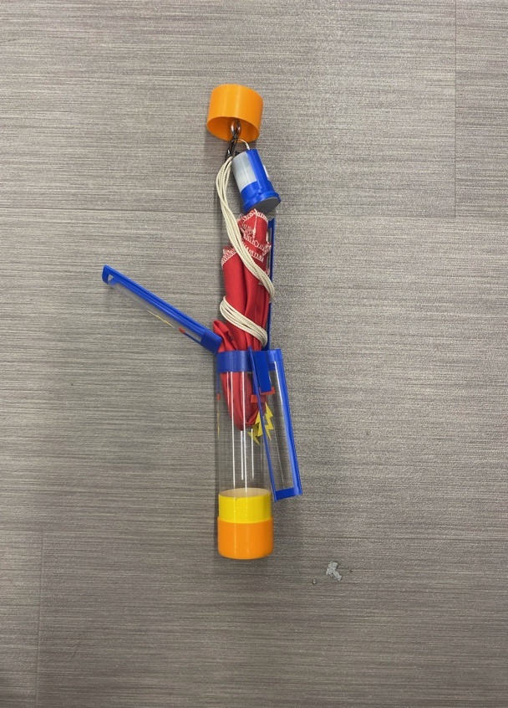

Figure 10: Assembly of parachute and payload in capsule.

## 3.2 Testing and Analysis

A passive parachute system has the responsibility to ensure the safety of landing from high altitudes for an abundance of different fields. Therefore, testing and analyzing the qualitative and quantitative data is a crucial aspect of guaranteeing safety before it is implemented into real world solutions. The testing that took place focused on isolating each individual aspect of the system. Taking this approach allows for a more in-depth analysis on the section being altered, which will impact another section and be noted. Transforming the capsule body into the three-panel opening system as described in section 3.1 Description of Final Design, was a large change resulting in an abundance of tests. The first section that was tested was the ability to open up and release the parachute. In the beginning stages the idea was to cut down the capsule with three lines, and not have them fully cutoff. This can be seen visually in Figure 11. Consequently, doing a multitude of drop any mores and observing that this was only to be more problematic as the capsule did not open more at all and only kept catching the parachute strings which led to an unsuccessful launch. Additionally, the team held activation parachute releasing simulations which gave immediate qualitive data.

Figure 11 : Visual of initial design before testing

Analyzing this data concluded the team to fully detach the panels as it was engineered to give the most consistent opens. However, the drawback from this approach was the potential loss of durability as the only tool holding the panels to the rest of the body was tape. A strength test was performed to ensure that as the system was launched the tape would not break or affect the functionality of the system. After a thorough analyzation the tape was deemed to be safe and able to be utilized in the current design. As a result of the satisfaction for each of the sectional testing of the model this produced the opportunity to bring it all together and complete a full closed test. This was done through shooting the capsule with a pressure of 30 psi while recording the results. These experimental results were then taken into a software called ImageJ which provides quantitative data which can be paired with the visuals assessments. The sections that were analyzed from these launching procedures included the durability, functionality, apogee, and travel path. Below in Figure 12, a visual that shows how the capsule functioned in mid-air which was ran through ImageJ.

ImageJ is a computer software utilized during this project. It provides accurate measurements, which allows the team to determine the apogee and other key moments of the launch. This information is important to obtain because it can show what aspects of the capsule and parachute release mechanism need to be improved or changed.

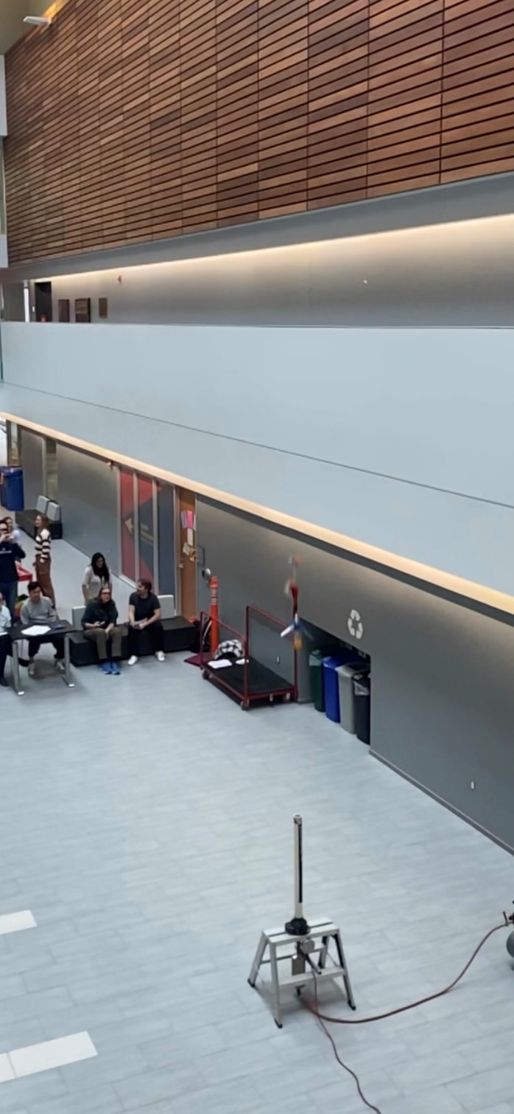

Figure 12 : Still image of panels doing the opening function as intended

This final test and data results leaves the team concluding that the design is working successfully and can be prepared for the final launch. Furthermore, the maximum apogee is measured again through the ImageJ software as well as the estimations using the table provided for the measurements of Mitchell Hall which can be seen below in Figure 13 and Table 1 respectively.

Figure 13: Parachute deployment system at max apogee

Table : Provided table of Mitchel Hall measurements.

|  |  |
| --- | --- |
|  | Height (m) |
| Roof Truss | 14.200 |
| Cedar Wall Top | 12.195 |
| Light Fixtures | 12.148 |
| Level 3 | 7.468 |
| Glass Railing | 4.900 |
| Level 2 | 3.810 |
| Level 1 | 0.000 |

# 4.0 Conclusion

The parachute deployment system designed was highly successful. The client was looking for a design that could simulate a delivery system for medical supplies which involved a parachute deploying within an altitude of 12 meters while carrying a payload. The challenge of his project was to design a passive deployment system that is reliable and consistent.

The design that the team developed stayed within the design constraints. It was simple, easy to use and allowed for a quick assembly and launch. The design used the materials that were provided by the client, and no additional materials were purchased resulting in a total cost of $0.00.

The number one design improvement that the team would have made with more time and test launches would be to increase the weight of the payload. The rocket apogee was almost 12 m each time which means that with a greater payload it would still travel an appropriate height while still being able to deploy the parachute on time.

# References

|  |  |
| --- | --- |
| [1] | National Library of Medicine, "Effect of parachute delivery on red blood cell (RBC) and plasma quality measures of blood for transfusion," 16 July 2021. [Online]. Available: https://www.ncbi.nlm.nih.gov/pmc/articles/PMC9290599/. [Accessed March 2023]. |
| [2] | P.A.R. Solutions, "Ultimate Drone Parachute System for All Multicopters, Fixed Wing, UAS," Fruity Chutes, 2019. [Online]. Available: https://www.ncbi.nlm.nih.gov/pmc/articles/PMC9290599/. [Accessed March 2023]. |
| [3] | D. Cavallari, "What is a model rocket?," Sports N' Hobbies, 6 March 2023. [Online]. Available: https://www.sportsnhobbies.org/what-is-a-model-rocket.htm.. |
| [4] | C. Gasmire, "How does a model rocket deploy?," The Model Rocket, 2023. [Online]. Available: https://themodelrocket.com/how-does-a-model-rocket-parachute-deploy/.]. . [Accessed 2023]. |
| [5] | N.A., "Definitions," Cornell Law School, N.D.. [Online]. Available: https://www.law.cornell.edu/cfr/text/14/105.3. [Accessed April 2023]. |
| [6] | Long Island Skydiving Centre, "What Parachute Types Are There?," Long Island Skydiving Centre, 2019. [Online]. Available: https://www.longislandskydiving.com/blog/what-parachute-types-are-there/. [Accessed 2023]. |
| [7] | DBpedia, "Drogue Parachute," n.d.. [Online]. Available: https://dbpedia.org/page/Drogue_parachute. [Accessed 2023]. |
| [8] | Code One, "C-130J JPADS: Smart Cargo, Ready To Fly," May 2013. [Online]. Available: https://www.codeonemagazine.com/c130_article.html?item_id=119. [Accessed 2023]. |
| [9] | Lab Rat Science Fiction, "LabRat Flight Page," n.d.. [Online]. Available: C-130J JPADS: Smart Cargo, Ready To Fly. [Accessed 2023]. |
| [10] | OER Services, "Drag Forces," OER Services Physics, n.d.. [Online]. Available: https://courses.lumenlearning.com/suny-physics/chapter/5-2-drag-forces/. [Accessed 2023]. |
| [11] | National Aeronautics and Space Administration, "The Drag Equation," May 2021. [Online]. Available: https://www.grc.nasa.gov/www/k-12/rocket/drageq.html. [Accessed April 2023]. |
| [12] | Apogee Components, "How to Fold a Parachute - Two Methods," n.d.. [Online]. Available: https://www.apogeerockets.com/Advanced_Construction_Videos/Rocketry_Video_361. [Accessed 2023]. |

# Appendix A: Individual Contributions

Table : Table of contributions of each team member

|  |  |  |  |
| --- | --- | --- | --- |
|  | **Content**  Identify here the sections of the report for which you contributed content. | **Write-up**  Identify the sections of the report that you wrote. | **Editing**   Identify the sections of the report that you edited. |
| Individual 1: Stacey Goldberg | Introduction | Introduction, Design process | Editing and proof reading of entire report, all formatting |
| Individual 2:  Elly Jones | Conclusion | Conclusion | Editing and proof reading of entire report, all formatting |
| Individual 3:  Conrad Bierman | Testing and Analysis | Testing and Analysis | Editing and proof reading my section of report |
| Individual 4:  Park Lan-Liu | Comparable systems, principles of parachute design, design process | Comparable systems, principles of parachute design, design process | Editing and proof reading my section of report |
| Individual 5  Max McCutcheon | Description of final design,  Design/testing/analysis | Description of final design,  Design/testing/analysis | Editing and proof reading my section of report |

# Appendix B: Cost Break-down

Client provided the materials listed below and shows in Figure 14 that were used for the design. No additional materials were purchased bringing the total cost for the design to $0.00.

* Capsule: Clear plastic tube, which is 30cm in length and has a 5cm diameter.
* Endcaps: One regular, and one with an eyelet and washer attached to it.
  + Proposed modification: holes cut to reduce pressure buildup inside capsule during launch
* Parachute: A hexagonal piece of red nylon fabric with strings attached at each point and has a surface area of 0.23m2.
* S – carabiner clip
* Canister: Used to hold the payload.
* Electrical tape: Blue, used to add additional support to the canister.

Figure 14:Visualization of the materials previously listed.

# Appendix C: Design Constrains

The following list of design constraints was set in place by the client.

1. Must always launch with a film canister (i.e. “dummy payload”) with either ~20 gm mass or  
   altimeter (that weighs ~20 gm) inside. Additional payload must be in the form of washers or  
   cars, and must be attached elsewhere. You cannot tape washers to the canister containing  
   the altimeter.
2. Film canister must be connected to a chute with a carabiner (i.e. detachable).
3. To be considered as a “payload”, elements must be connected to chute.
4. Weights cannot be attached to, or removed from the dummy load, inside or out.
5. Weights cannot be attached to the nose cap or end cap.
6. Designs will be rejected if unsafe (i.e. no protruding bolds or unprotected chutes)
7. If chutes are permanently altered (i.e. cut or stitched), they must be purchased (for real).
8. No form of lubrication allowed, dry or otherwise.